**Chapter 2-3**

**Asynchronous Programming with .NET using async and await**

**Using the task parallel Library in .net**

public async Task GetStocks()

{

using (var client = new HttpClient())

{

var response = await client.GetAsync($"http://localhost:61363/api/stocks/{Ticker.Text}");

try

{

response.EnsureSuccessStatusCode();

var content = await response.Content.ReadAsStringAsync();

var data = JsonConvert.DeserializeObject<IEnumerable<StockPrice>>(content);

Stocks.ItemsSource = data;

}

catch (Exception ex)

{

Notes.Text += ex.Message;

}

}

}

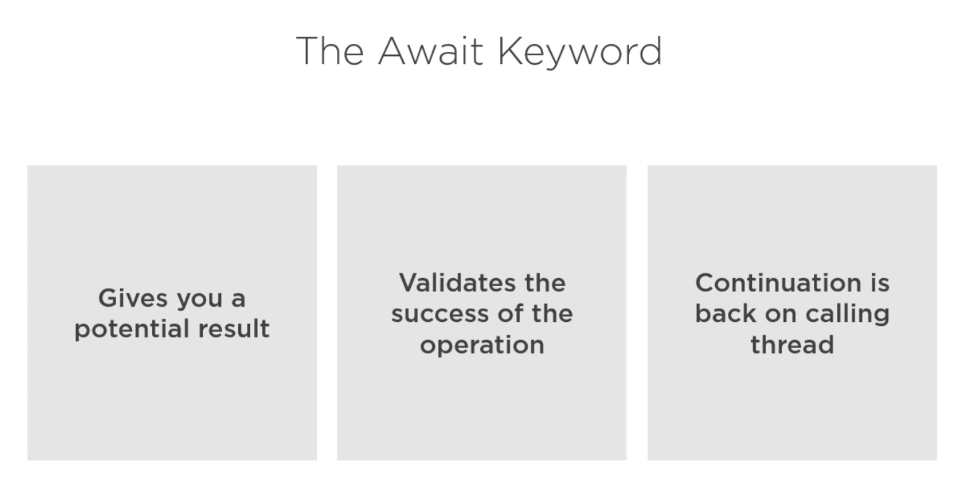

Only when you allow “async void” is for event handler

private async void Search_Click(object sender, RoutedEventArgs e)

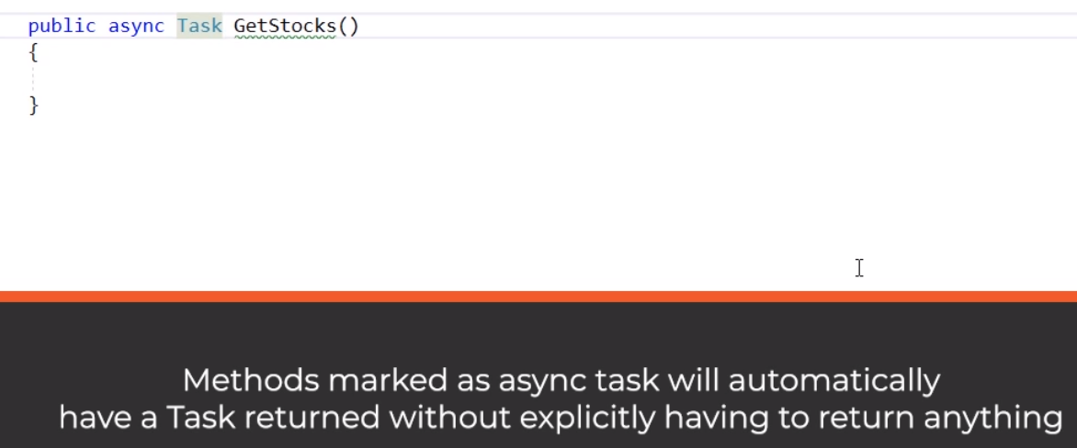

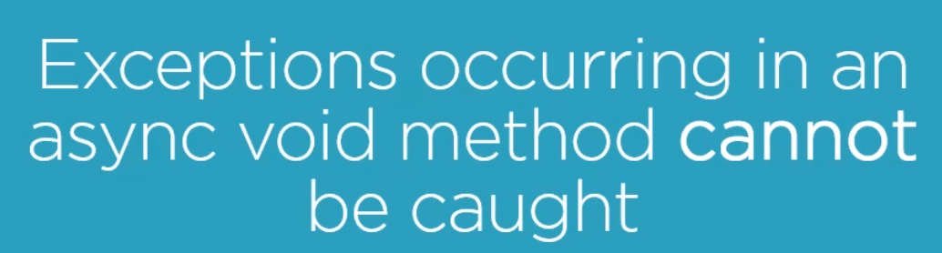

Use await and try catch everywhere.

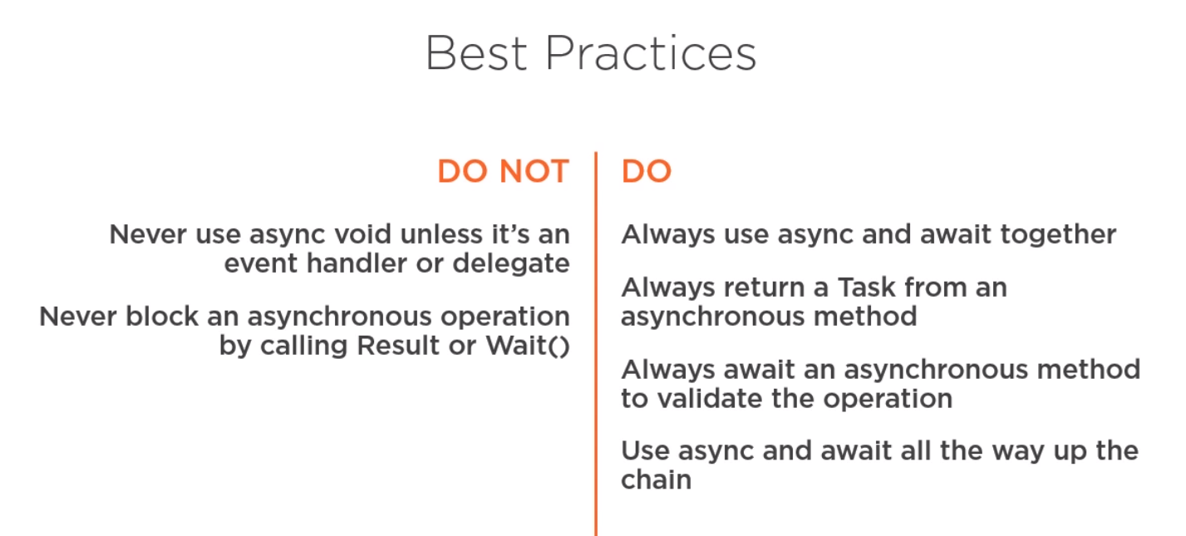

Task Parallel Library

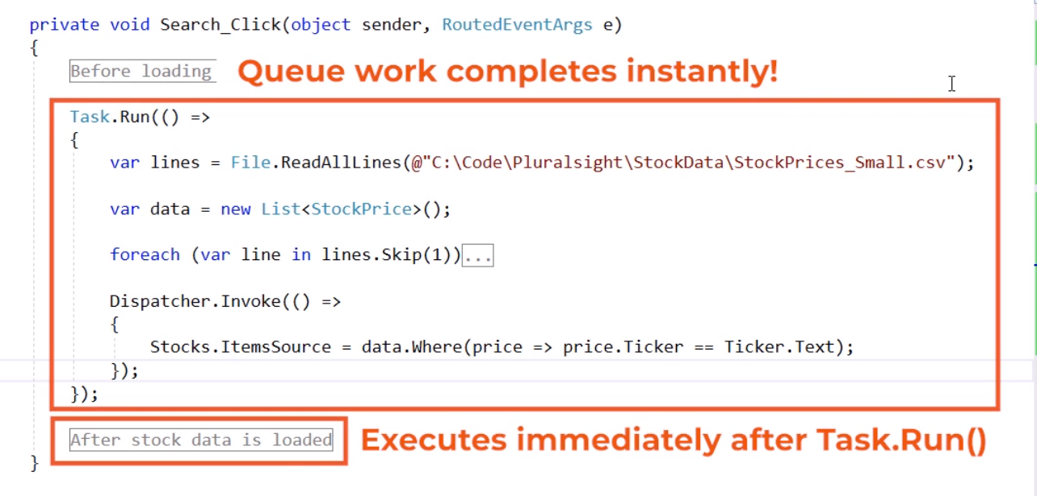

If your code was synchronized.

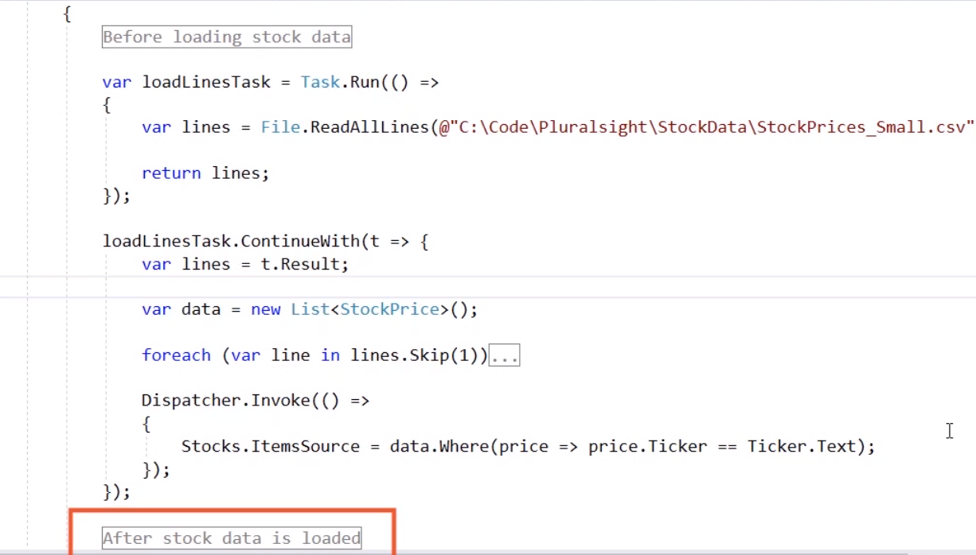

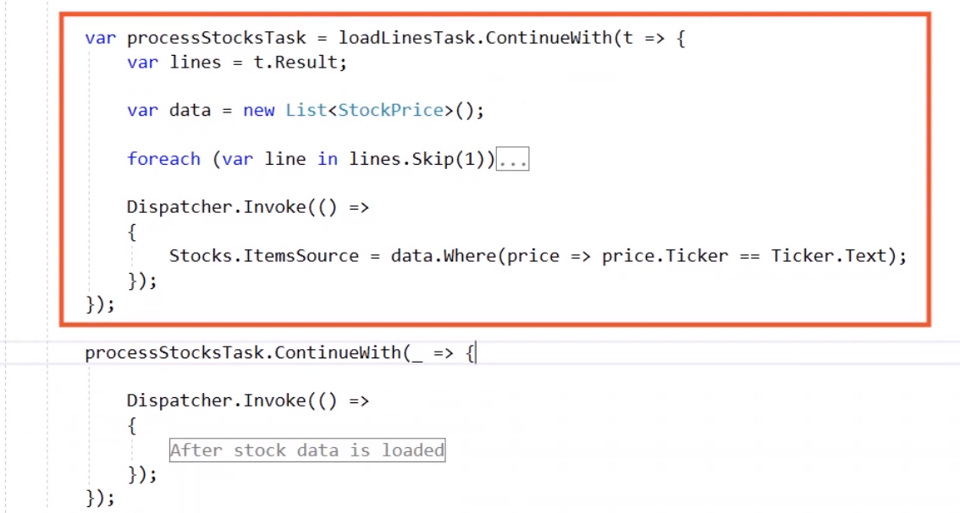

Very messy code; Just for pattern purpose

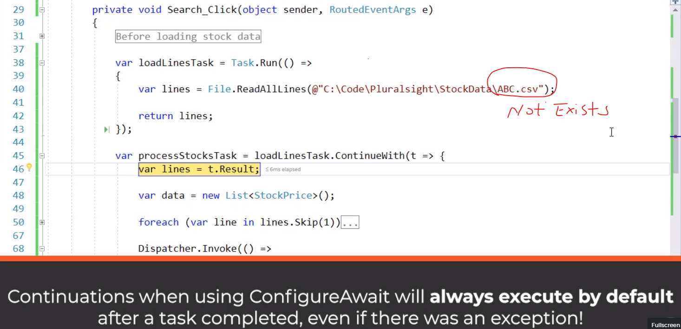

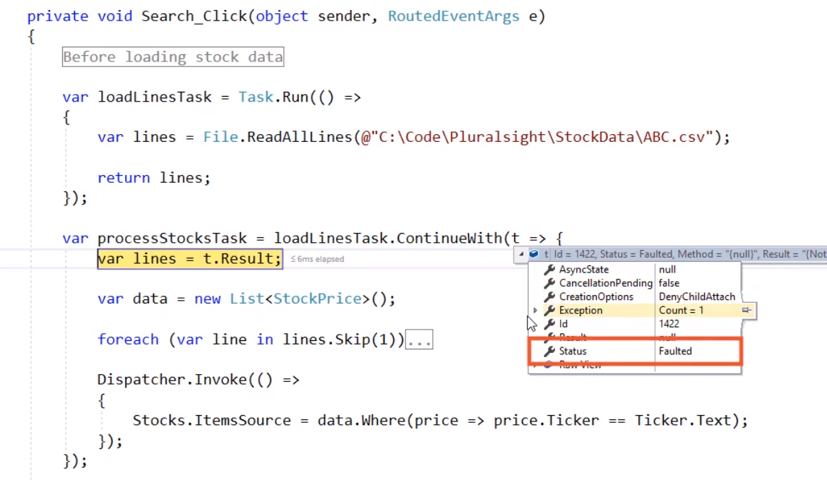

ONLK when execute next code block when TaskContinuationOptions is set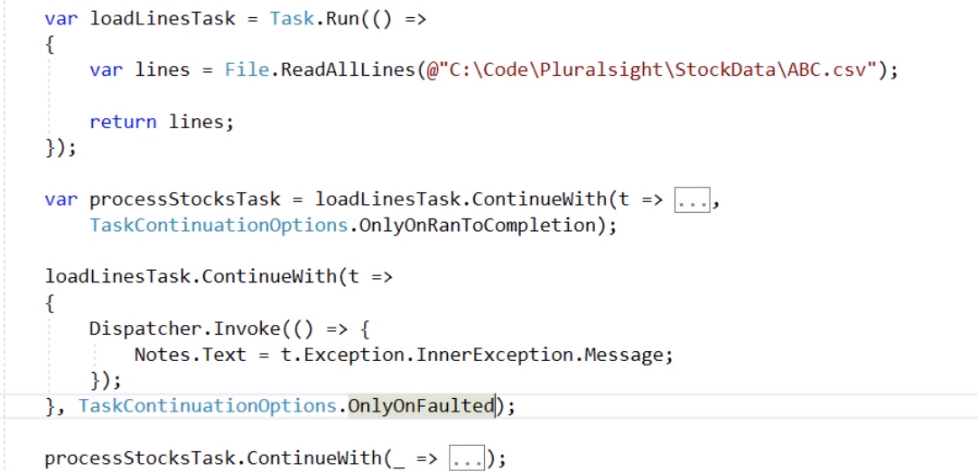

Cancellation

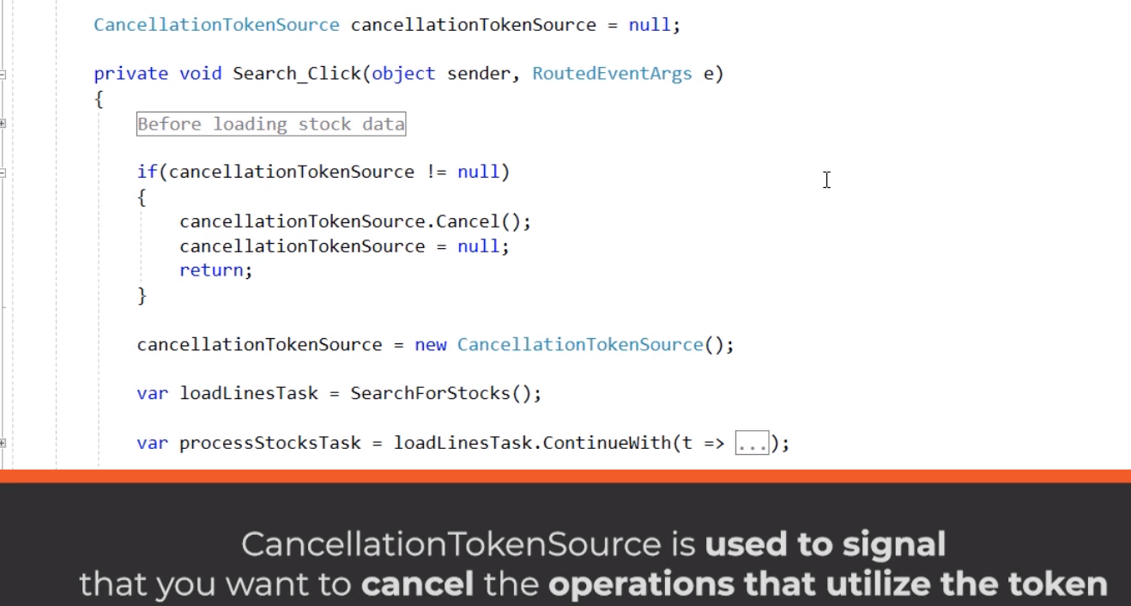

When you click search many times or Click “Cancel” to stop loading big datasets

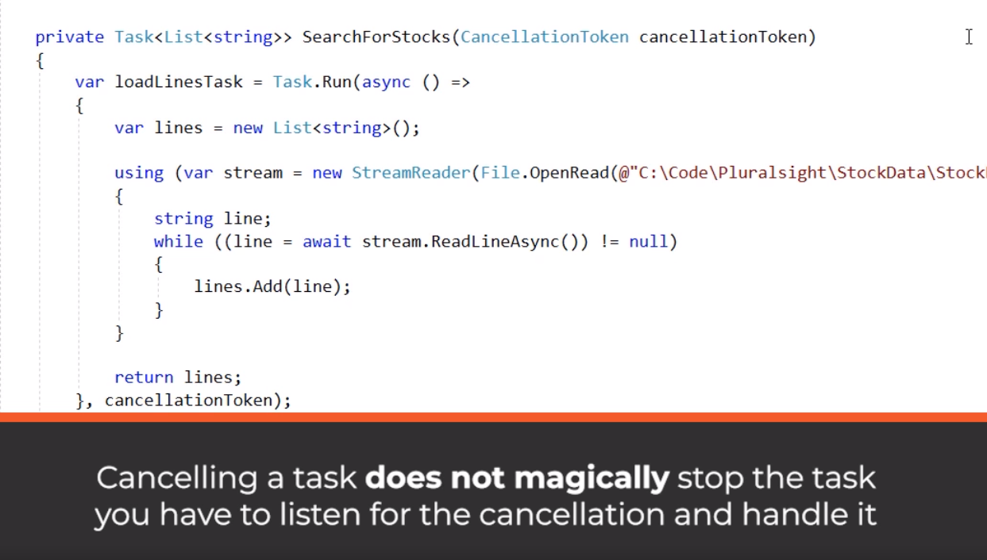

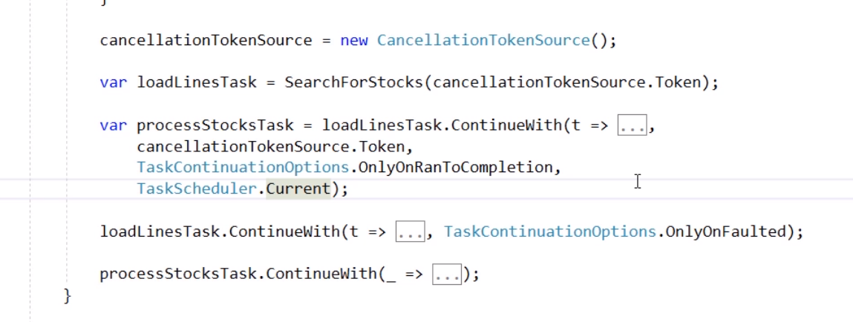

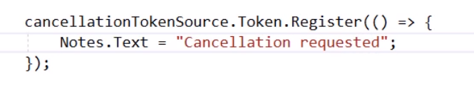

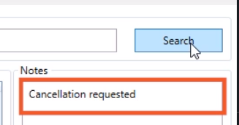

Finally solution about cancellation

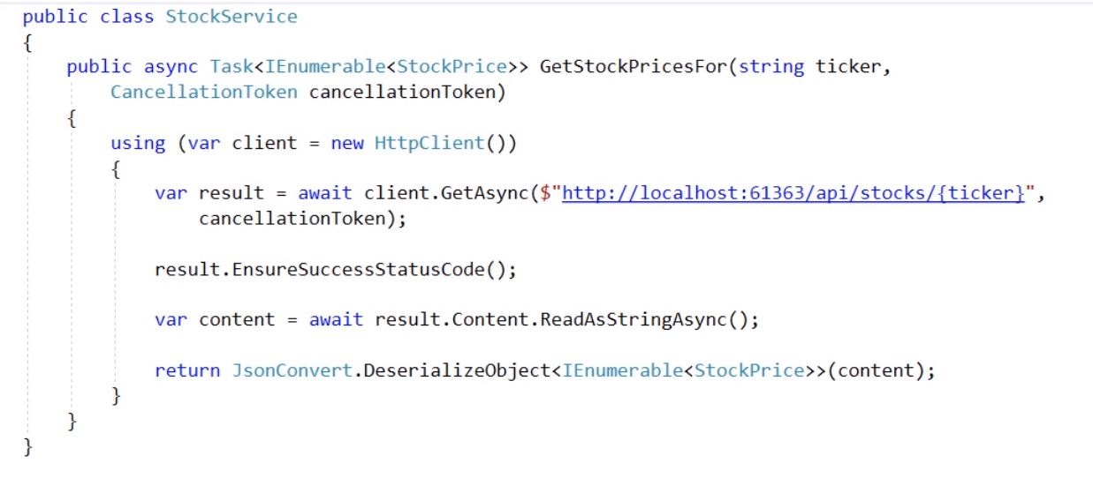

public async Task<IEnumerable<StockPrice>> GetStockPricesFor(string ticker,

CancellationToken cancellationToken)

{

await Task.Delay((i++) * 1000);

using (var client = new HttpClient())

{

var result = await client.GetAsync($"http://localhost:61363/api/stocks/{ticker}",

cancellationToken);

result.EnsureSuccessStatusCode();

var content = await result.Content.ReadAsStringAsync();

return JsonConvert.DeserializeObject<IEnumerable<StockPrice>>(content);

}

}

Parallel loading

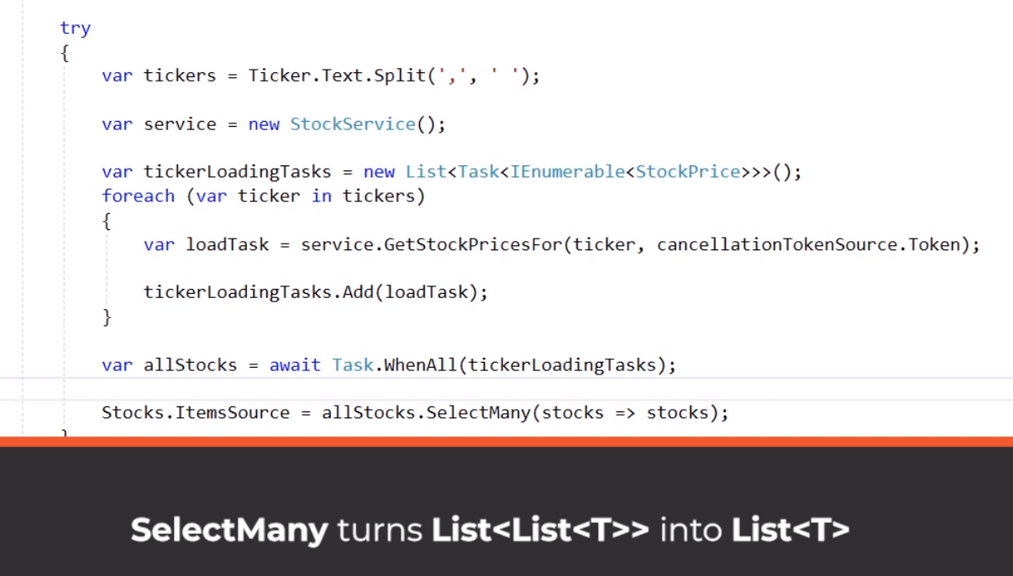

private async void Search_Click(object sender, RoutedEventArgs e)

{

#region Code to make sure Web API is running

// This code is just here to make sure that you have started the web api as well!

using (var client = new HttpClient())

{

try

{

var response = await client.GetAsync("http://localhost:61363");

}

catch (Exception)

{

MessageBox.Show("Ensure that StockAnalyzer.Web is running, expecting to be running on http://localhost:61363. You can configure the solution to start two projects by right clicking the StockAnalyzer solution in Visual Studio, select properties and then Mutliuple Startup Projects.", "StockAnalyzer.Web IS NOT RUNNING");

}

}

#endregion

#region Before loading stock data

var watch = new Stopwatch();

watch.Start();

StockProgress.Visibility = Visibility.Visible;

StockProgress.IsIndeterminate = true;

Search.Content = "Cancel";

#endregion

#region Cancellation

if (cancellationTokenSource != null)

{

cancellationTokenSource.Cancel();

cancellationTokenSource = null;

return;

}

cancellationTokenSource = new CancellationTokenSource();

cancellationTokenSource.Token.Register(() =>

{

Notes.Text += "Cancellation requested" + Environment.NewLine;

});

#endregion

try

{

var tickers = Ticker.Text.Split(',', ' ');

var service = new StockService();

var tickerLoadingTasks = new List<Task<IEnumerable<StockPrice>>>();

foreach (var ticker in tickers)

{

var loadTask = service.GetStockPricesFor(ticker, cancellationTokenSource.Token);

tickerLoadingTasks.Add(loadTask);

}

var timeoutTask = Task.Delay(30000);

var allStocksLoadingTask = Task.WhenAll(tickerLoadingTasks);

var completedTask = await Task.WhenAny(timeoutTask, allStocksLoadingTask);

if (completedTask == timeoutTask)

{

cancellationTokenSource.Cancel();

cancellationTokenSource = null;

throw new Exception("Timeout!");

}

Stocks.ItemsSource = allStocksLoadingTask.Result.SelectMany(stocks => stocks);

}

catch (Exception ex)

{

Notes.Text += ex.Message + Environment.NewLine;

}

finally

{

cancellationTokenSource = null;

}

#region After stock data is loaded

StocksStatus.Text = $"Loaded stocks for {Ticker.Text} in {watch.ElapsedMilliseconds}ms";

StockProgress.Visibility = Visibility.Hidden;

Search.Content = "Search";

#endregion

}

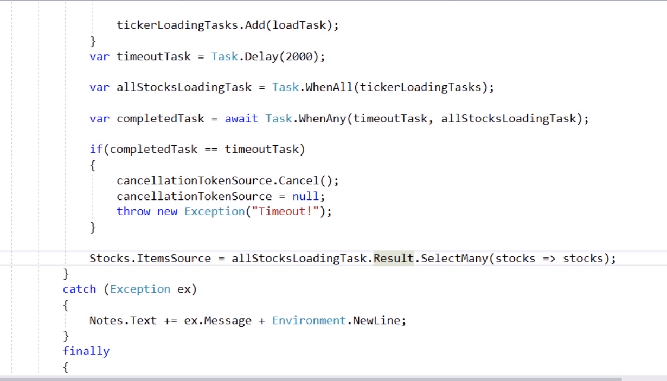

Mock up async task

public class MockStockService : IStockService

{

public Task<IEnumerable<StockPrice>> GetStockPricesFor(string ticker,

CancellationToken cancellationToken)

{

var stocks = new List<StockPrice> {

new StockPrice { Ticker = "MSFT", Change = 0.5m, ChangePercent = 0.75m },

new StockPrice { Ticker = "MSFT", Change = 0.2m, ChangePercent = 0.15m },

new StockPrice { Ticker = "GOOGL", Change = 0.3m, ChangePercent = 0.25m },

new StockPrice { Ticker = "GOOGL", Change = 0.5m, ChangePercent = 0.65m }

};

return Task.FromResult(stocks.Where(stock => stock.Ticker == ticker));

}

}

Thread safe collection

var stocks = new ConcurrentBag<StockPrice>();

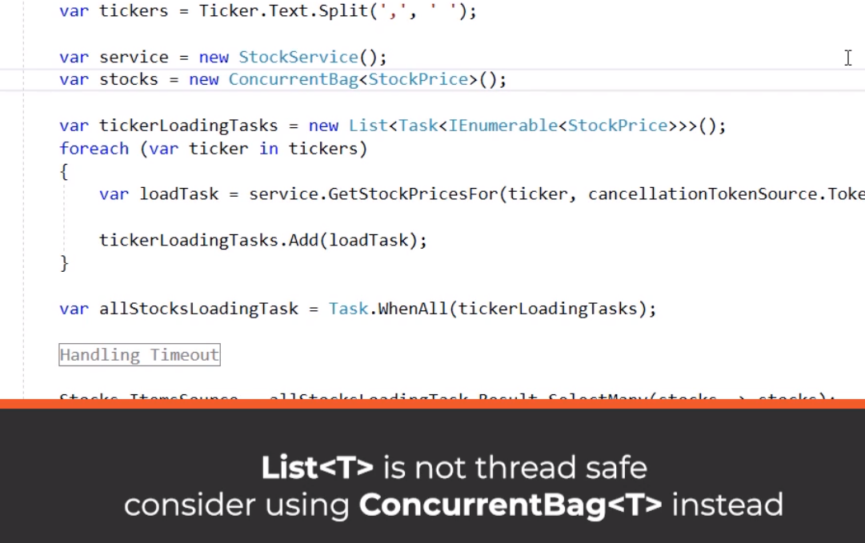

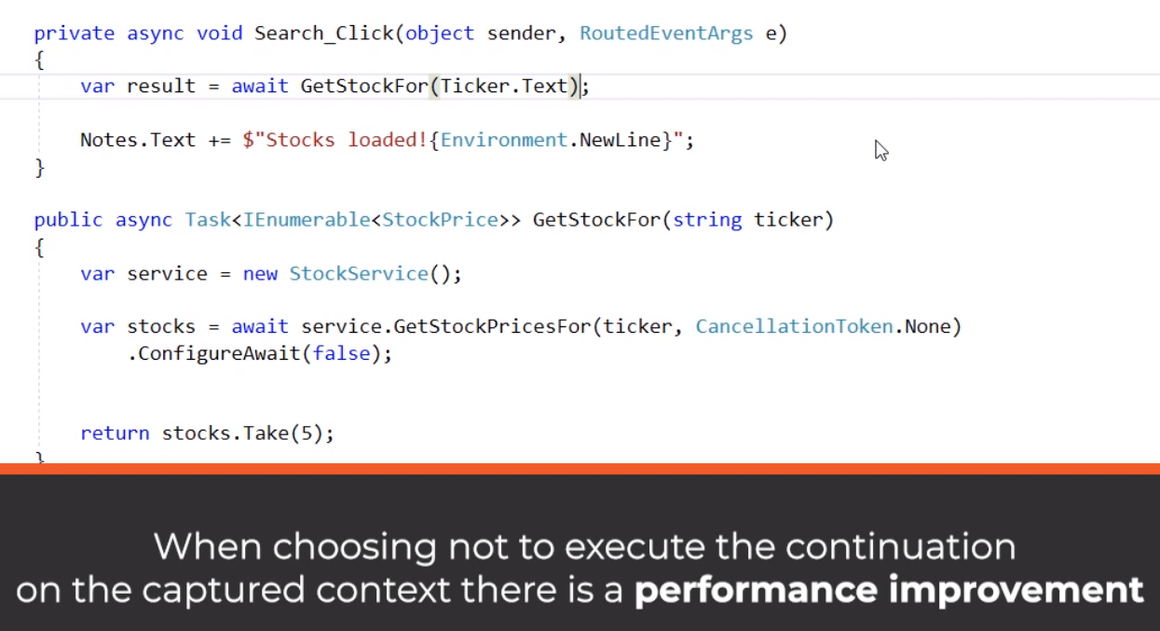

**ConfigureAwait only affect current method. Many thread info will be erased, which is for library developer.**

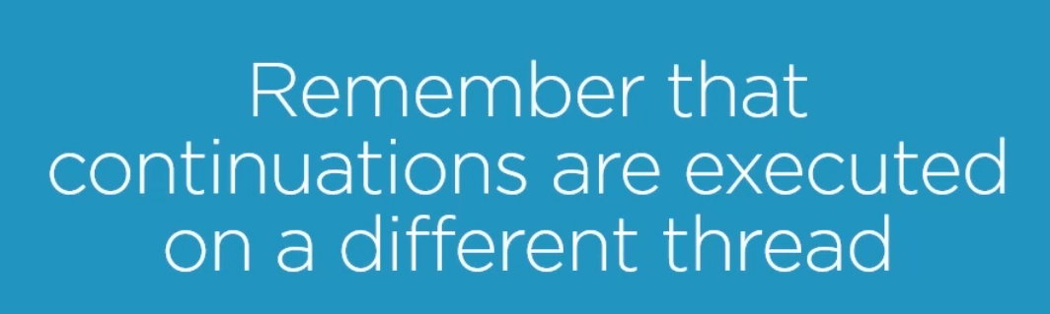

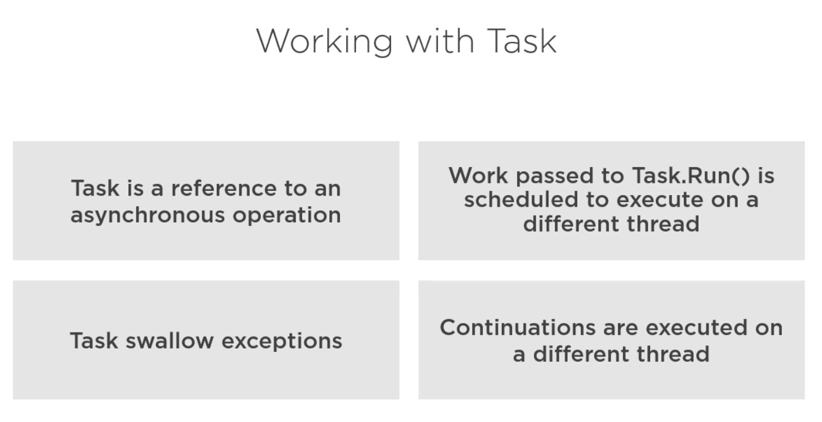

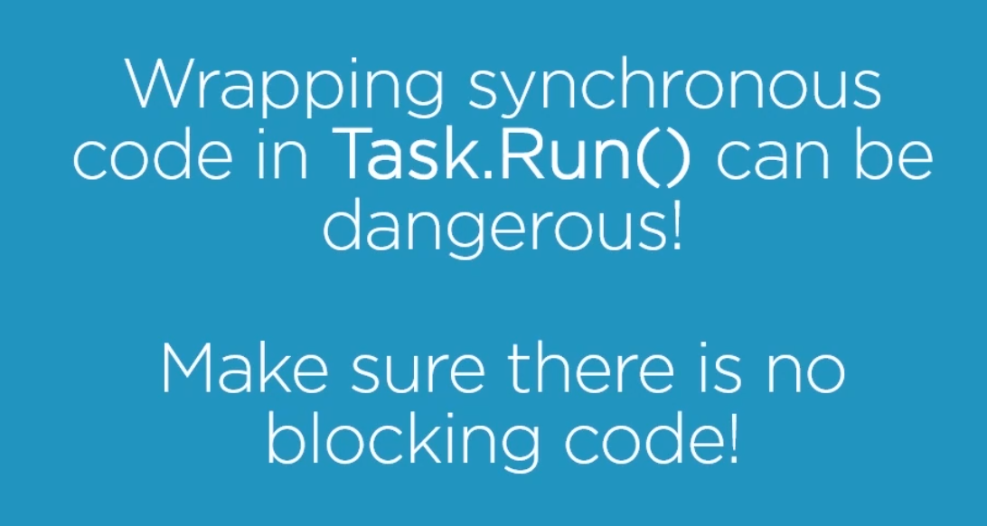

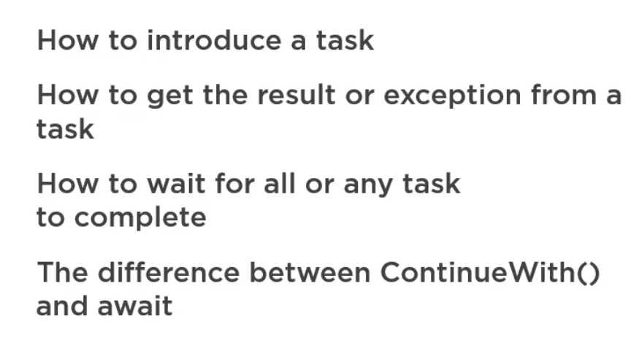

**Chapter 4 Parallel Programming using the parallel extension**

**System.Threading.Tasks.Parallel**

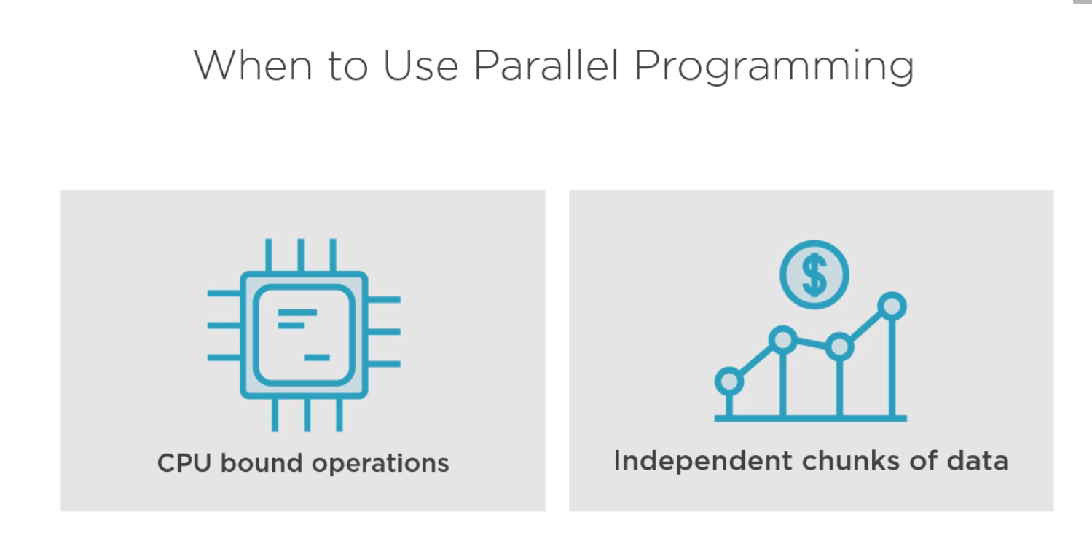

Parallel.Invoke(new ParallelOptions { CancellationToken = cancellationTokenSource.Token }…

* Lock the calling thread
* Parallel distribute workload our cpu or io but without sequence

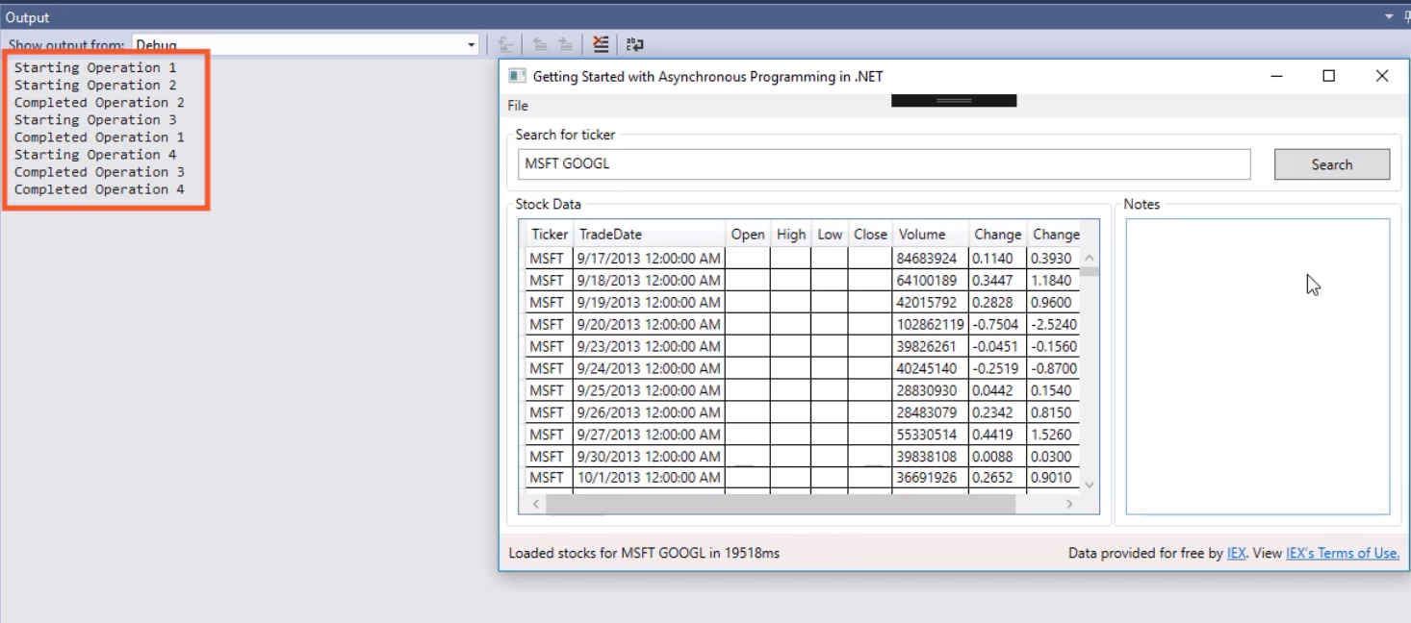

**Convert foreach to parallel (long run the method)**

var executionResult = Parallel.ForEach(loadedStocks,

new ParallelOptions { MaxDegreeOfParallelism = 2 }…

static object syncRoot = new object();

Parallel.ForEach(loadedStocks, stocks =>

{

var value = 0m;

foreach (var stock in stocks)

{

value += Compute(stock);

}

lock (syncRoot)

{

total += value;

}

});

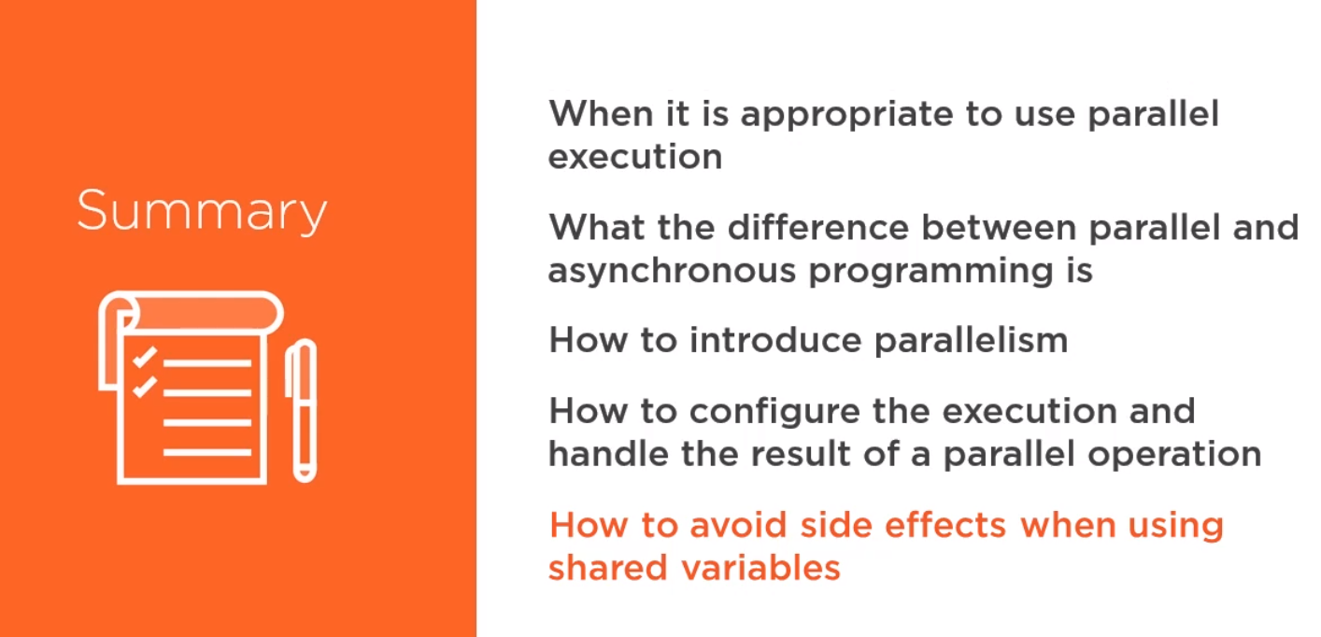

**Chapter 5 Asynchronous Programming Deep Dive**

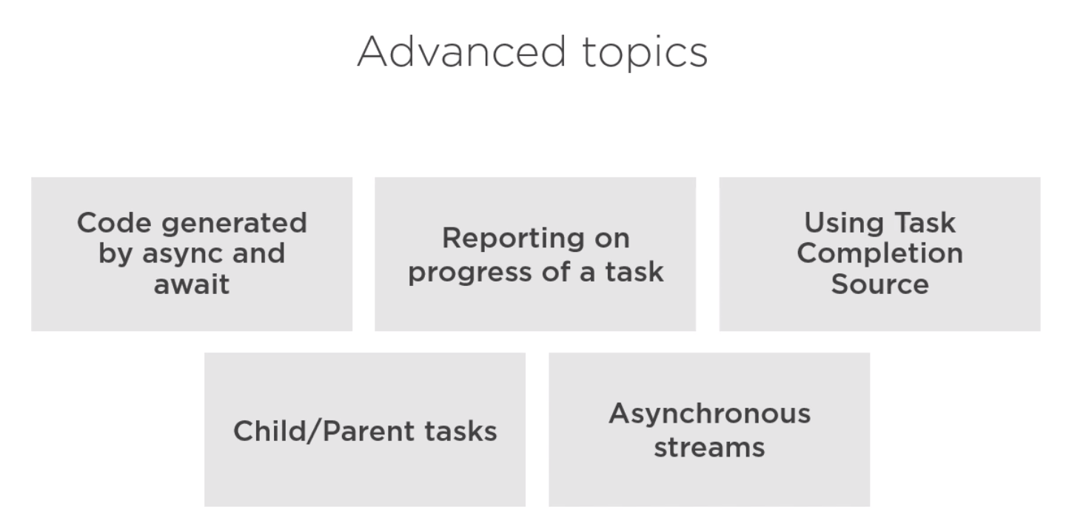

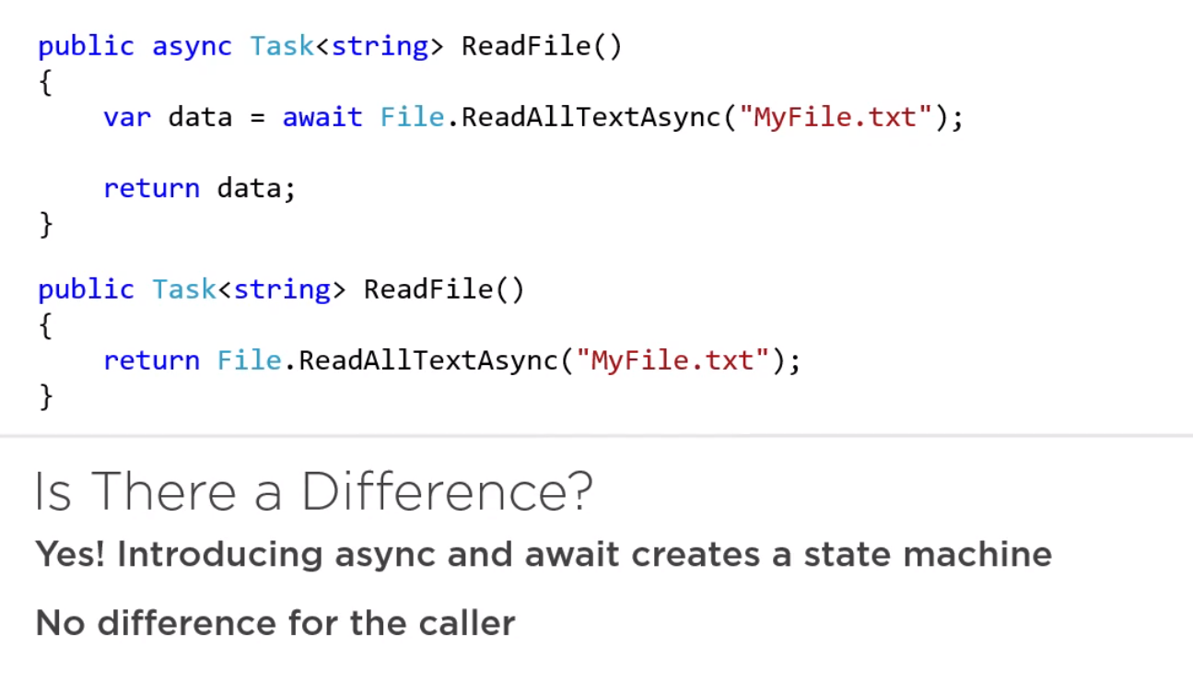

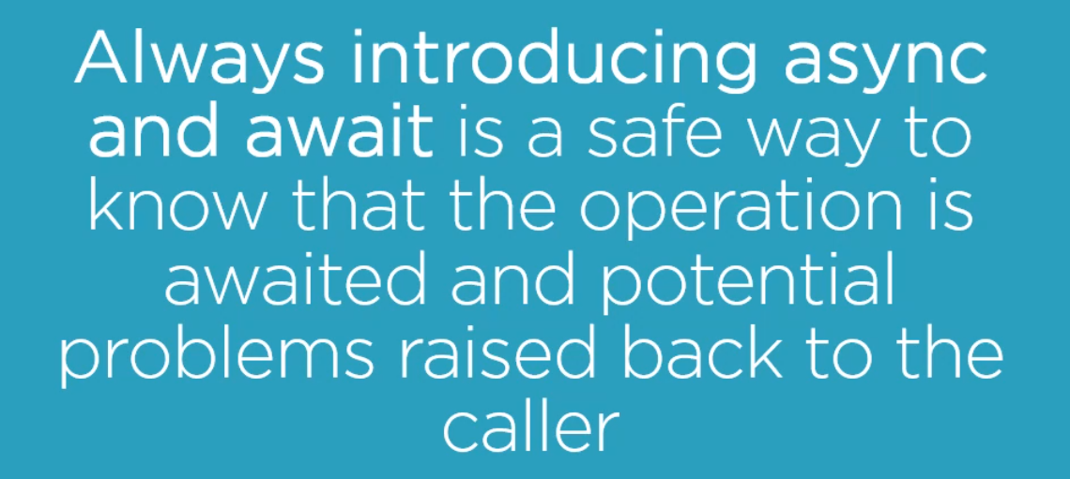

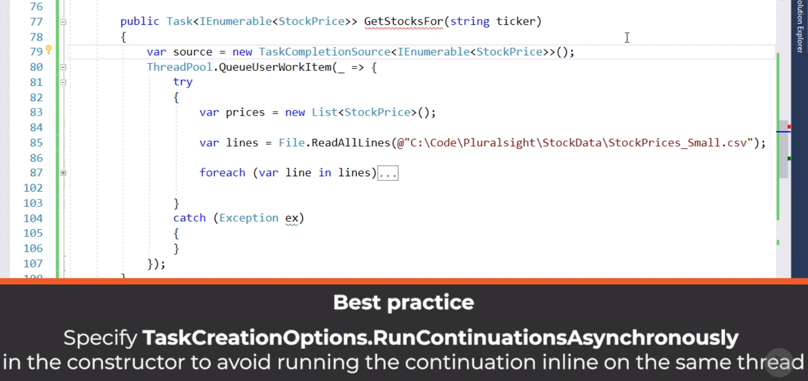

**Attach or detach tasks**

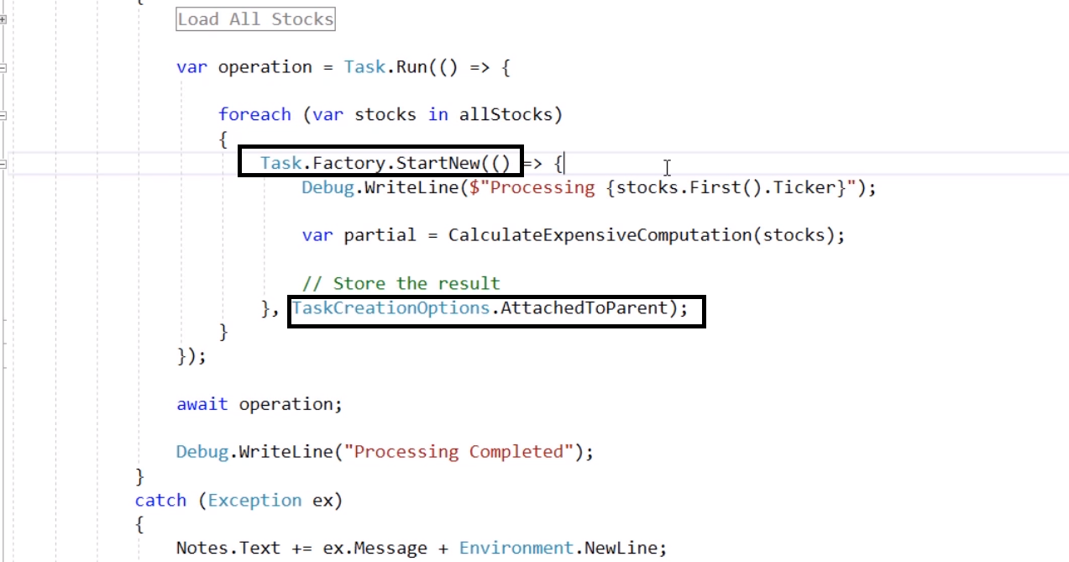

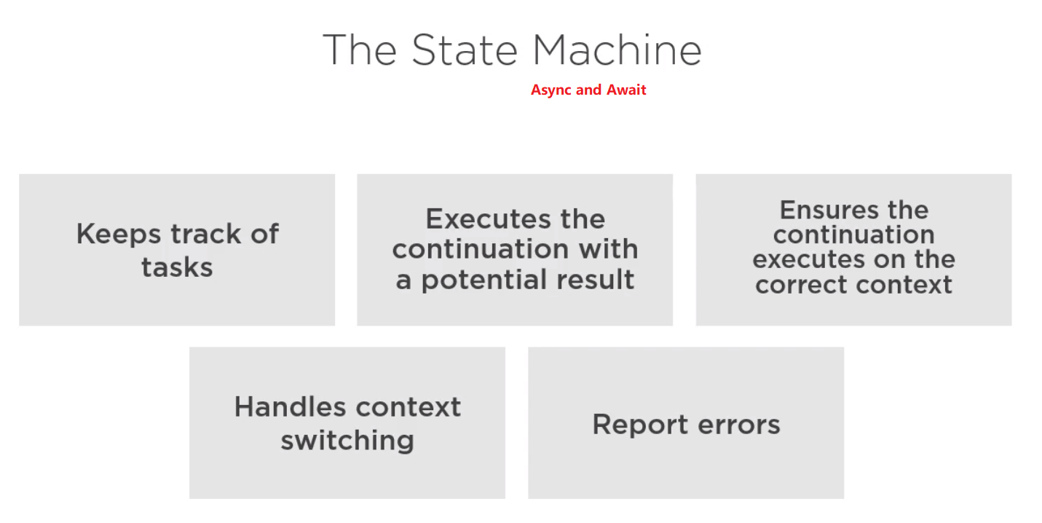

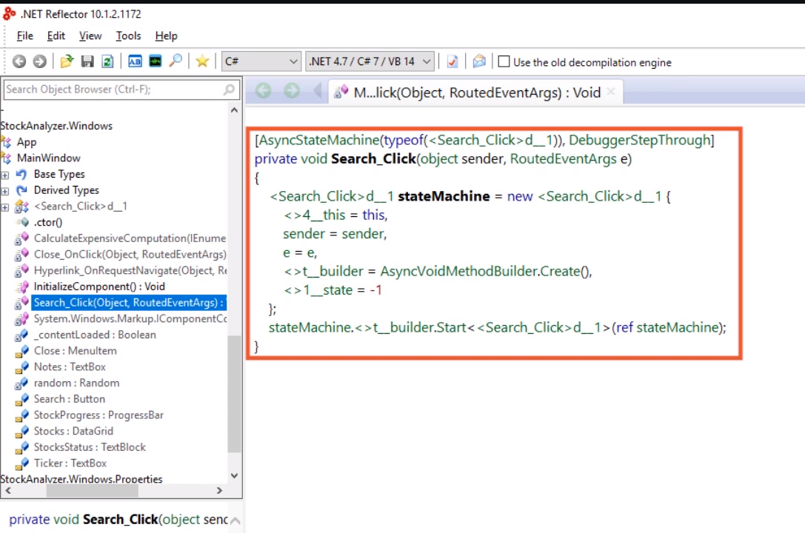

**Deadlock**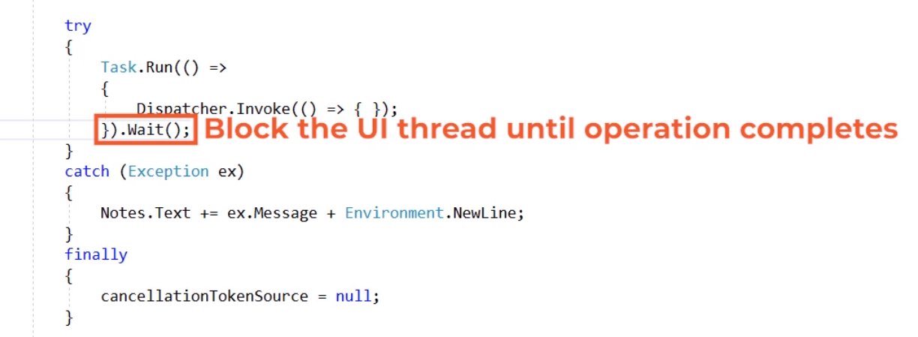

**Asynchronous Stream (StockAnalyzer.Windows.Core)**

**Process stock when one of them are valid.**

